Personal, Relevant Background, and Future Goals Statement Instructions
The Personal, Relevant Background, and Future Goals Statement Template has been formatted to the requirements of the GRFP Solicitation. Follow the instructions, then REMOVE all instructional text in brackets [], before you input your own content into the three-page Personal, Relevant Background, and Future Goals Statement.

General Instructions:
Outline your educational and professional development plans and career goals. Describe how you envision graduate school preparing you for a career in STEM, including how your experiences could contribute to scientific understanding and broadly benefit society. Your statement should include:

- Potential to advance knowledge in your field (Intellectual Merit)
- Potential to benefit society (Broader Impacts)
- Keep section headings exactly as shown: Intellectual Merit and Broader Impacts
- Other headings are allowed
- Follow all formatting rules listed
- Line break between sections
- Before submission, replace ALL instructional text with your own content
- Applications that deviate from this format will be considered non-compliant and will be returned without review (i.e., will not be considered for a fellowship).

Tips: Reviewers will look for evidence of:
- Active engagement with STEM communities
- Sustained interest in STEM
- Personal initiative and motivation
- Maturity and intellectual curiosity
- Growth through academic and professional experiences (problem solving, leadership, teamwork, perseverance, and strong communication skills)
- Vision for their future role in STEM
- Interest in addressing societal challenges

Personal, Relevant Background, and Future Goals Statement
Summary of Personal, Relevant Background, and Future Goals Statement: [Insert your Personal Statement here. This section must include both Intellectual Merit and Broader Impacts, under separate headings as shown below. Other headings and sections are allowed.]

Intellectual Merit
We look for the applicant's ability to:
- Plan and conduct research
- Work as a part of a team
- Interpret and communicate research (e.g., through publications, or presentations)
- Take initiative
- Think creatively
- Solve problems
- Persist and overcome challenges
- The applicant’s demonstrated intellectual ability (as indicated by grades, coursework, awards, etc.)

Broader Impacts
We look for the likelihood that the applicant’s activities will:
- Increase participation in STEM
- Improve STEM education in schools through outreach and mentoring
- Increase public scientific literacy and public engagement with STEM through community outreach
- Increase collaboration among academia, industry, and other types of organizations
- Improve education and educator development – at any level – in STEM
- Improve the well-being of individuals in society
- Develop a globally competitive STEM workforce
- Improve national security
- Increase the economic competitiveness of the U.S.
- Enhance infrastructure for research and education.

Summary of Personal, Relevant Background, and Future Goals Statement
I am applying for the NSF Graduate Research Fellowship Program to continue my PhD and Master’s research at the University of South Carolina with Dr. Yi Wang, where my focus is radar-guided labeling and physics-aware radar-camera perception for small maritime targets. I chose this lab due to three primary reasons; (a) a lab culture that pairs camera and radar expertise, (b) a clear runway to extend the work I began as an undergraduate, and (c) a partnership with an industry partner that keeps the work practical and increases my global impact.

My long-term plan is to complete the Ph.D., serve at a national laboratory such as NIWC or NRL advancing maritime sensing for national security, then eventually teach at a university so more students find their way into research – as well as teaching them some of the cool stuff in engineering that I enjoy and think others would find interesting.

Initially, wireless communication is what got me interested in antenna design, which led me to radar, where I discovered that maritime applications had a significant hole in the science. Small objects on the water are visually ambiguous and numerically rare, and although work is being done for camera-based detection, the amount of labelled data is rather limited. Radar, although able to detect these small objects, does not provide as much detail as camera, and therefore is harder to do object classification in, so fusing them is both hard and necessary. Its challenge is precisely what engages me; if one approach is blocked, I shift to a related task and continue making progress.
[Image 1 — side-by-side photo/screenshot of camera view vs. radar view of a boat]

My preparation for this project is both hands-on and cross-disciplinary. I received a B.S. in Mechanical and Electrical Engineering with a minor in Computer Science in May ’25 with a GPA of 3.66. The courses that prepared me the most for the work in this project were RF Communications, Controls, Signal Processing, FPGA design, and, most practically, Project Management, which I use almost daily to plan experiments and run teams. I’m also fluent with CUDA, PyTorch, ONNX, OpenCV, Linux, Git, some Docker, and C++ for low-level radar I/O. I’ve built my own radar simulation suites, deployed to Jetson Orin, worked with Furuno/Simrad radars and RGB/thermal cameras, and use our GPU servers and the Hyperion HPC.

The immediate research arc is to use radar to cue automatic image labeling, which depends on first making radar detections accurate and efficient. Today the radar dataset is roughly 200k radar sweeps (~56 hours) sourced from South Carolina lakes, Charleston, and Hampton Roads, VA, with ~20% night and ~5% bad weather. To create Ground Truth data, we instrument the lab boat and MOKAI with GPS and use camera cross-checks and double-labeling for quality.
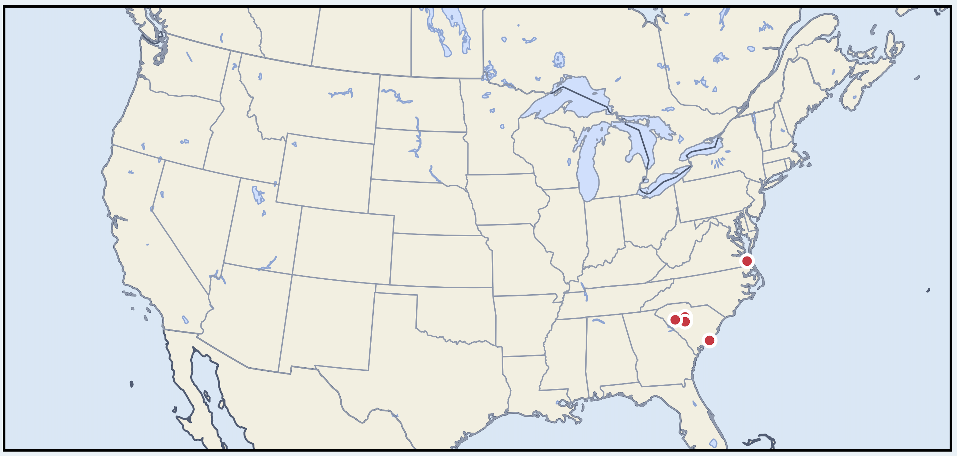
Figure 1: Data Collection Locations
Primarily, I plan to exceed the SOTA commercial baseline (commercial baseline – Tocaro Blue) on accuracy for land-vs-object and boat-vs-buoy while using ≤10% of the labels their supervised system requires. The idea is to improve accuracy while also reducing labelling efforts, which is costly and rather drab.

Intellectual Merit
My plan combines three elements into a single system and evaluates them on real data. First, a radar-only self-learning path that pretrains on range-azimuth sweeps using masked reconstruction (MAE-style), then freezes the backbone and trains a lightweight detector on a very small labeled subset, with variable-context temporal windows added later to exploit motion cues and derive accurate velocity and heading. The goal is to perform better than SOTA with ≤10% labels and to improve small-object performance.

Second, a fused radar-camera model with physics-awareness. The model links radar cells to image patches via rectification and imposes two checks that reflect the sensors’ geometry: (a) make features align where the sensors agree, and (b) convert range/bearing into a loose search region in the image, encouraging the camera box to overlap it. I’ll also allocate special queries and sampling for tiny objects, which are otherwise easy to miss. [I wanna be more specific here, basically I want the model to pay more attention where radar says there is an object, via a few methods, but I think the best way is to upscale the image, then analyze it with a model focused on those smaller objects.]

Third, deployable, real-time variants and a production-ready system setup. This will involve 2 parallel paths. Sub-path 1 involves compressing the best models, measuring latency and power on embedded hardware. Sub-path 2 will use vetted models to auto-label large pools of data, curate the best slices, and train compact supervised models on those labels. This keeps training practical and pushes the system toward field use.
[Image 3 — a one-page system diagram: left column “data collection,” middle “radar-only self-learning → fusion model,” right “edge deployment + auto-label curation.”]

During my first year on this team, I built our end-to-end radar control and GUI that connects the radar to compute, exposes all settings, and supports field ops. Early on, when I tried to run multiple experiments back-to-back, the system started dropping data between runs. After instrumenting the pipeline, I found a worker thread constantly polling for parameter changes; under load it starved the ingest thread. I redesigned the thread model and added a ring buffer; the drops disappeared. That experience reinforced a habit I now bring to every project – deployment is part of the sensing stack.

My prior projects cultivated the same instincts. In laser powder-bed fusion I wrote the FEA software to predict thermal stress and deformation, presented a poster, and received continued funding for the project, which I completed in sophomore year. Later, when I migrated to structural health monitoring (SHM) I developed the FEA validation to align a UAV-deployable sensor network with commercial simulations and co-authored a Springer chapter. Later on that same project, I designed flexible antennas for the sensors using additive manufacturing. I later used that flexible electronic skillset to co-develop a heart-rate/IMU wearable for a childhood activity study.

I meet weekly with my advisor; weekly with the CV/ML and hardware teams; every two weeks with the radar team; brief an agency quarterly; and check in with an industry partner each semester. That cadence forces clear communication and end-to-end planning. On the scholarly side, I’m leading three manuscripts for January submission in conferences – High-Dynamic-Range Radar via Clipping-Aware Multi-Gain Fusion, Adaptive Gain Selection for Radar via Entropy Maximization, and Pulse-Diverse HDR Imaging for Robust Radar Targeting – and recently presented “Seeing in Binary: Resolving Details from Low-Bit Sensors” to roughly a hundred stakeholders.
[Image 4 — a figure showing multi-gain fusion & entropy-based gain selection & pulse diversity.]

Broader Impacts
There is still no widely adopted open benchmark for detecting small maritime objects on affordable radar plus cameras; existing datasets are small or tied to expensive sensors, which slows algorithmic progress. My project addresses that hole in the research field by releasing cleaned, documented data with tooling and an initial benchmark that lowers the barrier to entry and standardizes evaluation so others can improve on it. The exact name of the dataset is to be determined, but the intent is to enable reproducible research on sensors that real operators can afford.

I’ll measure scientific impact with a few specific goals. Within a year after the dataset and benchmark release, I am targeting 300+ downloads, and six external benchmark runs. By the second year, I want to see 800+ downloads, at least a dozen external evaluations, and a greatly enhanced dataset release with more weather conditions and sea states, as well as a v2.0 benchmark release. The goals for the final embedded system remain strict. I am aiming for ≥30 FPS at ≤100 ms end-to-end, with at most a 3% accuracy drop for land-vs-object and 7% for boat-vs-buoy relative to the non-compressed model.

Education and workforce development run through everything I do. I aim to have mentored three to four undergraduates by the end of the first-year of my Master’s, and aim to have one or two novel co-authorships from them. By the first year of my Ph.D., I aim to have six to eight undergraduate mentees working on each of the separate aspects of the radar-camera pipeline. I plan to continue to TA for courses, as well as help design more interactive courses with practical, cool demos. I’ll also keep doing hands-on outreach with local high schools – VEX events and engineering demos like a Tesla coil, an electric go-kart, mechanical-advantage rigs, and prop-car builds – because tangible artifacts are what flip the switch for many students.

Partnerships help the work matter outside of academia. NIWC has offered data sharing; NOAA and the Coast Guard are natural collaborators; and I will continue working with our industry partner that focuses on ruggedizing and packaging technology. I’ll release code and a benchmark with a clear I/O schema, reference baselines, scoring tools, and a simple leaderboard, while keeping the data governance strict: signage at collection sites; blurring vessel names and faces; GPS-based location jitter when appropriate; and encryption of raw data.

